Ryan Ringer

I worked alone on this exercise.

Regular expression (Regex)

group practice

1. Google and read about why regular expressions are useful. Can you list 3 places that regex is used?

Regex is used in command line interfaces in linux when using commands such as grep. It is also used in search engines; Google has the functionality to use regex in is searches. Regex is a capability in many programming languages like Python and Java.

1. This is the interactive tutorial site for regex (<https://regexone.com/lesson/introduction_abcs>). The first 10 lessons are the most used elements which will be useful for your HWs and exams. You need to complete the 10 lessons to be ready for next week’s content.

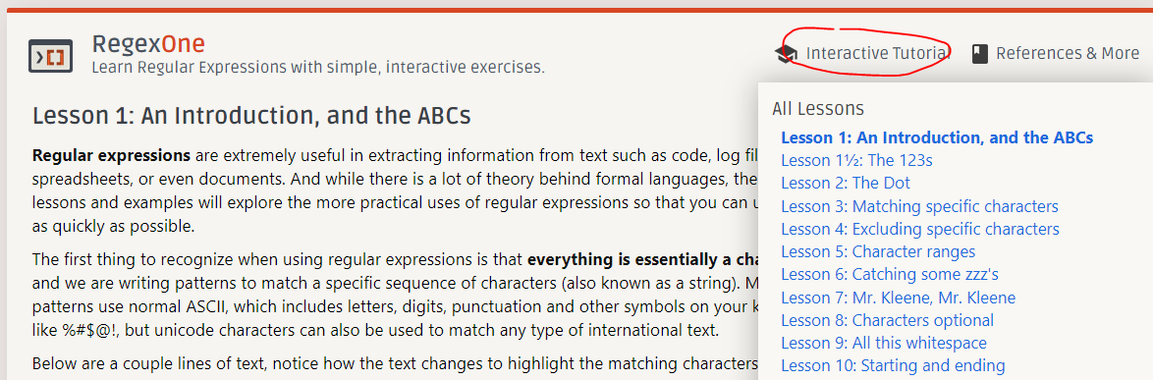

1. This is the interactive regex building tool (<https://regexr.com/>). Please get familiar with the website and locate the cheat sheet. You can use both websites to complete below regex practices.

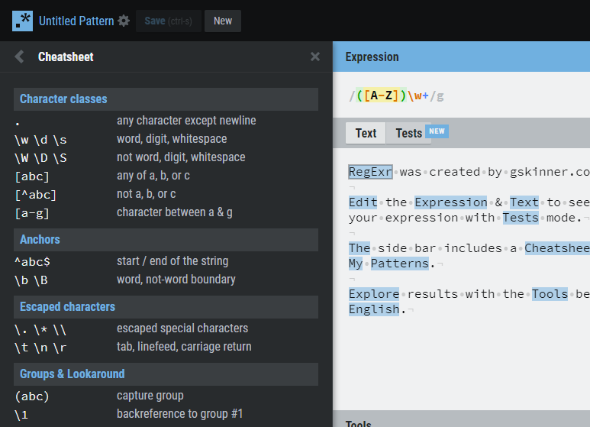

1. Work with your coding partner(s), write down regular expression for the below items, test them out in the website.
   1. An integer

^[-+]?\d+$

This can only check one line in regexr; regexr has the expression default as “//g” instead of “//gm”

The best I can get to work for this is

\d+ but it does not handle decimals properly

^[0-9]+$

* 1. A float consists of 1 or more digits before and after decimal point

\d+\.\d+

* 1. A float with exactly 2 digits after the decimal point

\d+\.\d{2}$

* 1. A float end with letter f (4.321f)

\d+\.\d{2}f

* 1. Capital letters, followed by small case letters, followed by digits

[A-Z]+[a-z]+\d+

* 1. Exactly 3 digits, followed by at least 2 letters

\d{3}[A-z]{2,}